Prop. 1  
Evan Feusi

**Optimizing Landfill Methane Utilization: Spatial Multi-Criteria Analysis for informing Energy and Public Health**

Landfills are a significant source of methane (CH₄) and other hazardous airborne pollutants, posing both environmental and public health risks. LFG is typically about 50% methane and 50% CO₂, with trace components of non-methane organic compounds (NMOCs) – some of which are toxic pollutants (e.g. benzene, vinyl chloride) associated with increased rates of cancer and respiratory diseases in surrounding populations​.

Many older dumps (closed before the 1980s) were simply covered with soil and lack modern liners or leachate controls. Encroaching developments have raised concerns about groundwater contamination and community exposure. At the same time, the methane produced by landfill decomposition can be exploited as an energy resource - its capture for flaring or DNG generation can (in certain cases) reduce odors and hazards while providing biomass energy.   
 For my project, I’ll be proposing an SDSS which integrates both spatial analysis and a multi-criteria decision matrix to prioritize landfills for methane recovery and determine the most viable LFG utilization method (flaring, energy generation, pipeline injection, or direct-use). Infrastructure Feasibility (distance to gas pipelines, power grids, industrial users), Regulatory/Energy Potential (LFG volume, compliance needs, economic viability), and Environmental Justice considerations (proximity to populations, NMOC levels, groundwater contamination risks) will all be weighed to determine the optimal LFG utilization method for ~~several key landfill sites across New York State.~~ a *single landfill site* in NYS (maybe 2 or 3)[1]. I will be focusing on the Old Bethpage Landfill Site (Old Bethpage, NY), which currently does have a GCCS unit, however, with inactive incinerators. The penultimate goal is to deliver some (imaginary) heuristic framework that both environmental agencies and developers could use to reach a consensus on project selection.

**1. Data Sources:**

* Likely will use the NY State DEC Databases to map active municipal, industrial and inactive landfills ([List of Active Industrial Waste Landfills](https://dec.ny.gov/sites/default/files/2024-03/listindcomlandfill.pdf), [2020 MSW Landfill Capacity Chart](https://dec.ny.gov/environmental-protection/waste-management/solid-waste-management-facilities/municipal-solid-waste-landfills/2020-capacity-chart)). The DEC’s [Inactive Landfill Reports](https://dec.ny.gov/sites/default/files/2024-07/inactivelandfillrpt2024.pdf)(2021–2024) contain investigations of old landfill sites, including any findings on groundwater contamination and perhaps rudimentary risk assessments. (Also check out Leaching/NMOCVL: [Municipal Solid Waste, Industrial or Ash Landfill Annual/Quarterly Report](https://dec.ny.gov/sites/default/files/2024-01/lfannrt.pdf))
  + [data.gis.ny.gov](https://data.gis.ny.gov/datasets/db9225d3962c4f8891fb72231b752ec5_31/about#:~:text=Inactive%20Solid%20Waste%20Landfills%20,was%20last%20updated%20on%201%2F34%2F2023) is also a great source for point-coords of inactive landfills.
* EPA Landfill Data (LMOP): The U.S. EPA’s Landfill Methane Outreach Program (LMOP) maintains a nationwide database of landfills and LFG energy projects​ ([epa.gov](https://www.epa.gov/lmop/basic-information-about-landfill-gas#:~:text=Basic%20Information%20about%20Landfill%20Gas,of%20landfill%20gas%20energy%20projects)). From LMOP, its possible to obtain attributes like waste in place (tonnage), whether an energy project exists or is planned, and the status of the landfill (open/closed). This may be useful especially for larger sites and for cross-checking which NY landfills already have LFG utilization. LMOP also designates “candidate” landfills as discussed (≥1 million tons waste, recently closed, no project)​ ([eesi.org](https://www.eesi.org/files/042613_Tom_Frankiewicz.pdf#:~:text=These%20data%20are%20from%20LMOP%E2%80%99s,designated%20based%20on%20actual%20interest%2Fplanning)); this could serve as a starting point for identifying high-potential sites.
* Emission Factors/Tech References: Emissions and performance data from technical literature will likely hold the most weight in comparing LFG utilization methods for my purposes. For instance, the [EPA's AP-42 Chapter 2.4](https://www3.epa.gov/ttnchie1/ap42/ch02/draft/db02s04.pdf#:~:text=,to) (which provides emission factors for landfill gas flaring and energy devices)​, and other EPA reports (like the 1995 EPA report on LFG utilization, can supply figures for NOₓ, CO, and other pollutants emitted by flares vs engines vs turbines.
* EIA 923/860 - emissions data forms

**2. Decision-Making Matrix**

I plan on using a multi-criteria decision-making matrix to systematically evaluate the site for methane recovery. A higher score represents the greatest feasibility for LFG utilization. (weights are subject to change).

| **Decision Criteria** | **Weight (%)** | **Description** |
| --- | --- | --- |
| Methane Generation Potential | 20% | Estimated LFG output (e.g., cubic feet of methane per minute). Larger gas flows improve project feasibility. Sites producing >1 million cubic feet per day (~28,000 m³/day) are typically considered economically viable for energy recovery. |
| Proximity to Energy Infrastructure | 15% | Distance to natural gas pipelines, electric substations, or industrial users. Sites close to existing energy networks score higher, as infrastructure availability reduces project costs. |
| Regulatory Status & Compliance | 15% | Landfills already subject to NSPS/EG gas collection requirements may have existing infrastructure, reducing investment needs. Sites near the 34 Mg NMOC/yr threshold are prioritized for preemptive mitigation. |
| Environmental Justice (EJ) & Community Impact | 30% | Evaluates population density, proximity to overburdened communities, and pollution burden (EPA EJSCREEN data). Landfills near low-income/minority communities with high health risks (asthma, cancer incidence, VOC exposure) receive higher priority. |
| Landfill Status & Capacity | 10% | Active sites with years of operation remaining support long-term projects. Recently closed landfills still generate gas, while older, inactive sites may have declining methane output. |
| Environmental & Land-Use Constraints | 10% | GIS analysis of hydrology (floodplains, aquifers), protected areas (wetlands, conservation zones), and land use restrictions. High-risk areas may receive deductions due to regulatory hurdles or construction limitations. |

**3.** **Scoring System / GIS Implementation**

Using the shapefile data provided by the DEC, I could implement a system for determining best course-of-action via an initial score for infrastructure proximity and environmental justice impact:

| Distance to NG Pipeline | Score (0-15) |  | % Low-Income / Minority Population Nearby | Score (0-20) |
| --- | --- | --- | --- | --- |
| ≤ 5 km | 15 (high feasibility) |  | 75% | 20 (high priority for mitigation) |
| 5-15 km | 10 (moderate) |  | 50-75% | 15 (moderate) |
| >15 km | 5 (low feasibility) |  | <50% | 10 (lower priority) |

For single-site analysis, I would want to map areas where gas emissions are highest around the landfill (seeing as it covers 68 acres) - this information should be available with pretty great granularity from NYSDEC reports.[2] I’m going to provide below some more advanced methods of spatial analysis to use in further iterations of my model:

1. Airborne gas spread/Pipelines: As it exists, the facility has 33 gas-recovery wells and 6,500 feet of collection headers (which I can georeference using NY DEC records and aerial imagery). Hopefully, with a bit more research, I’ll be able to digitize the pipelines/vents as a line network with flow attributes and perform a network analysis to determine LFG collection efficiency (although I don’t think this is feasible with my current information). A more realistic approach would be to just use surface emissions mapping - NYC open data should have existing Optical Gas Imaging (OGI) data which is used to map real-time methane flux. It’s possible I could interpolate point-based sensor data (using inverse distance weighting) to try to generate some continuous raster layer of methane concentrations. Overlaying with wind speed and direction data (from NOAA), some basic model of downwind methane dispersion patterns could be developed(?). *(Windrose plot for region right)*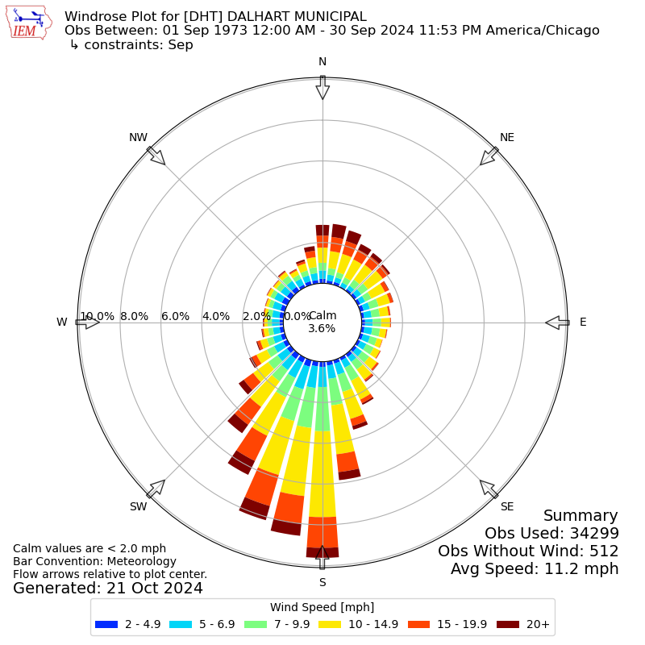
2. Residential Zone proximity: Using Road Networks (from NYS GIS Clearinghouse), Residential Property Boundaries (NC) and maybe a map of Underground Utilities (gas, water, electric) [should be able to get this data, as it’s publicly available, but I would likely have to reach out to the county myself], I could perform a buffer analysis to determine how far emissions extend into residential zones and calculate the number of affected households per gas concentration threshold. (based on Long Island Zoning Atlas - allows for overlay districts and environmental abatement policies: <https://www.longislandzoningatlas.org/>. 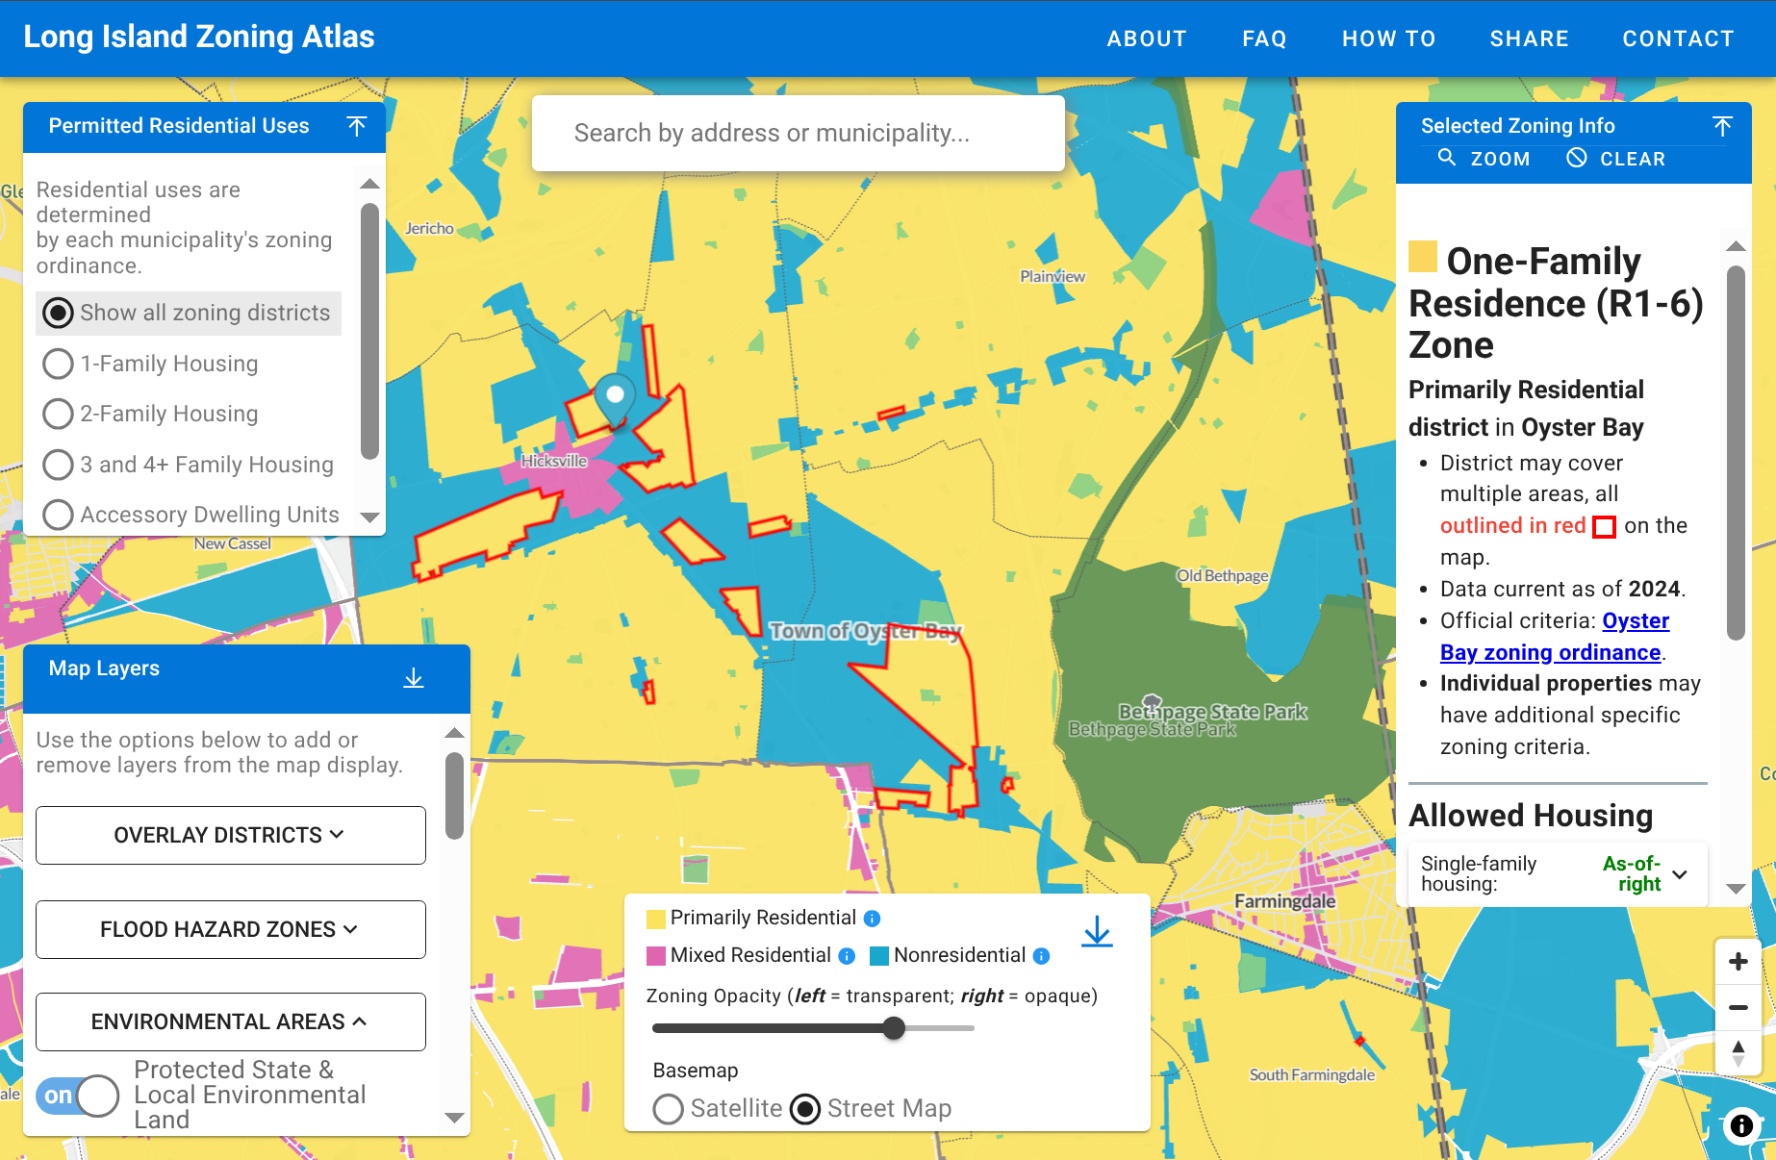
3. Gas Migration from Soil type: Soilmaps from the USDA NRCS SSURGO Database seem like a promising option to evaluate soil composition/permeability for gas retention and migration risk. Permeability ratings could be assigned to each soil type (e.g, clay=low permeability, sand=high permeability) - I’ll have to do some more research, but I assume that gas migration will occur in corridors with low porosity and large grain size. (Below: Map of soil suborders in suffolk - CGIS; [NYSERDA dataset](https://nyserda.maps.arcgis.com/apps/webappviewer/index.html?id=86307666eff54c829c57b6f2d30cb7e0) )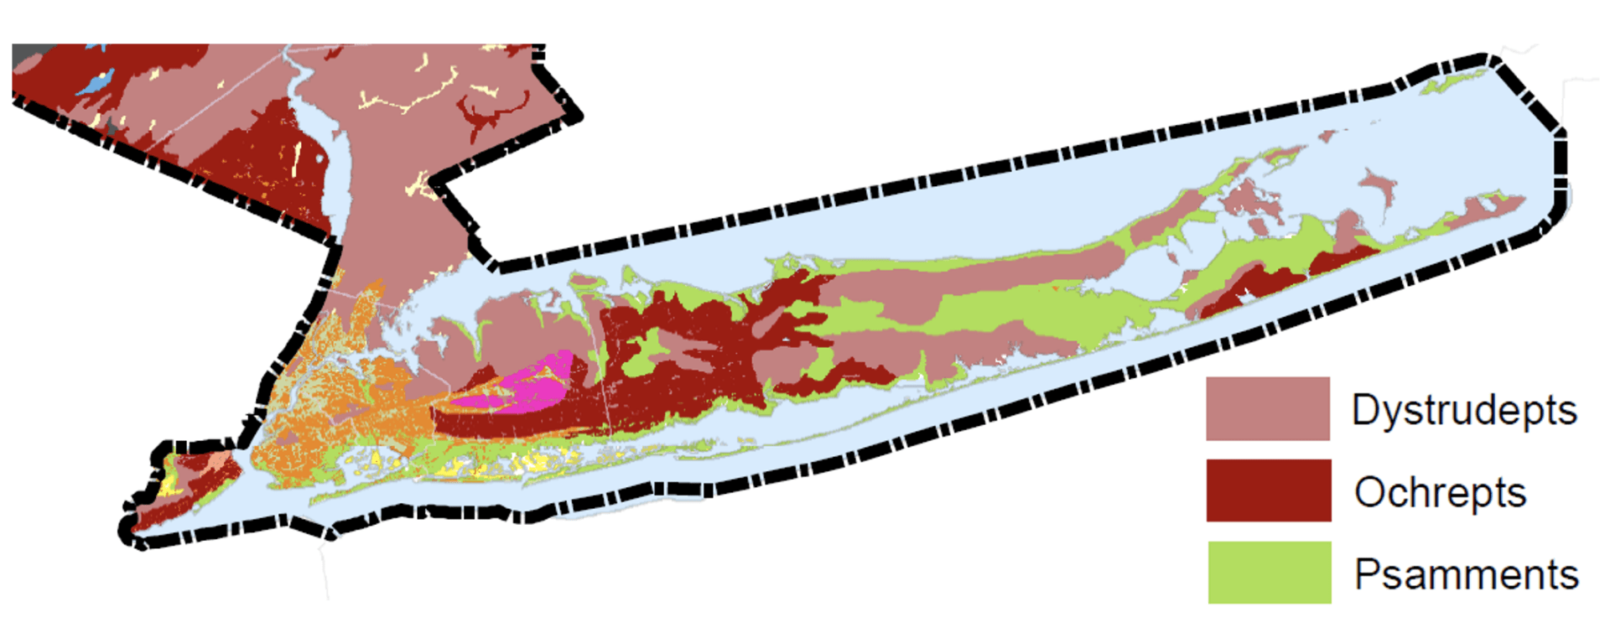
4. Hydrological Risk Analysis: Can use surface water bodies & watersheds (from NYS GIS), leachate monitoring wells (from EPA superfund reports), and Groundwater flow maps (USGS aquifer studies - lloyd aquifer?) as input to model where contaminants might enter nearby water bodies. Lloyd aquifer is pretty well-guarded, but I would be more concerned with nearby open water bodies (Carlls River, Sold Spring Brook, etc). ([USGS hydr. risk tool](https://ny.water.usgs.gov/maps/li-dtw/)[†])

If the landfill is shown to introduce great risk to nearby communities, flaring might be prioritized as an immediate option. Further collaboration between Environmental Groups, Landfill Operators, and Local Govt. would be required to see if better long-term options are available (see (6)).

I’ve yet to develop a solid framework, but I think results will be determined similarly to what follows:

| **Scenario** | **Outcomes (typically)** | **Relevance from Geospatial analysis** |
| --- | --- | --- |
| RNG Injection | Cleanest Option - high processing cost (not worthwhile if not a lot of methane) | Proximity to gas pipelines + capacity analysis |
| LFG Energy (Turbine/Engine) | Moderate cost, moderate emissions | Distance to substations, EJSCREEN overlay |
| Compliance-Driven Flaring | Lowest cost, highest emissions (but good short-term emergency option) | Emission dispersion modeling + health risk mapping |
| No Expansion | Constant Emissions (regulatory risk) | Air quality impact analysis + regulatory compliance overlay |

**4. LFG Utilization Methods (Explanation)**  
Options are weighed on emissions profile, infrastructure requirement, and economic feasibility. Weights should include environmental regulations (like NOx limits), site economics, and of course, community/environmental considerations.

**The general options for dealing with landfill gas (once collected) are as follows[3]:**

1. *Flaring (Open or Enclosed)* - CH4→CO2, reducing GHG impact by ~87%, but emits NOx and CO. If chlorine compounds are present, dioxins/furans may form, though proper design minimizes this. Relatively simple Infrastructure (just require a gas collection system, blower, and flare stack). Gas pretreatment is minimal (usually just moisture removal) because flares can handle “dirty” gas.
   1. Usually a compliance measure rather than a revenue generator - has the lowest capital and O&M cost, but no energy product created. Typically chosen when gas volume is too low for energy recovery or when no feasible offtake exists.
2. *LFG-Energy* - Can be done with Internal combustion engines, gas turbines, or emerging fuel cells. (~100->50,000 MW). Gas cleanup requirements are moderate – usually filtration and sometimes compression – lower than pipeline injection standards. Projects have medium capital cost - revenue comes from selling power to the grid. Classified as renewable energy in many states, making it eligible for Renewable Energy Credits (RECs).
   1. All convert methane to CO2, however, engines in particular have relatively high NOx and CO emissions ([atsdr.cdc.gov](https://www.atsdr.cdc.gov/hac/landfill/html/ch5.html#:~:text=The%20choice%20of%20which%20type,using%20an%20internal%20combustion%20engine)). In areas with strict air quality regulations (e.g., ozone nonattainment areas), NOx emissions can be a barrier to using IC engines.
   2. Gas turbines have slightly lower NOₓ per kWh than reciprocating engines at large scale, and fuel cells produce negligible NOₓ (because they are non-combustion
3. *Pipeline Injection* - Renewable Natural Gas (RNG) - LFG is upgraded to pipeline-quality gas (~95% CH4) and injected into the natural gas distribution system. The upgrading process involves removing CO₂, O₂/N₂, H₂S, VOCs, and other impurities. This process itself has a modest emissions footprint: primarily CO₂ vented from separating methane (which is far less climate-impacting than releasing the CH₄). On-site combustion is minimal (only small heaters or generators for process energy), so local NOₓ and CO emissions are very low.
   1. Essentially, RNG projects transfer the combustion to end-users offsite. This means near-zero onsite criteria pollutants; however, the methane ultimately gets burned by end consumers (or in vehicles), producing CO₂ at that point
   2. Has the most intensive gas processing requirements… They require a gas upgrading plant (membrane separators, pressure swing adsorption or similar technology, plus H₂S removal, drying, and sometimes cryogenic separation) and compression to pipeline pressure. A pipeline interconnection is needed. Some projects build several miles of pipeline to reach the grid. Plant capacities often need a minimum flow (usually feasible at larger landfills generating >~1000 scfm of gas).
4. *Direct-Use of LFG* (Local Thermal or Industrial Use) - Involved sending Landfill gas (usually moderately treated) to a nearby boiler, kiln, greenhouse, etc. Generally, boilers have the lowest NOx and CO emissions among combustion options. Thus, using LFG in a boiler can minimize criteria pollutants compared to flares or engines. VOCs are still destroyed by burning. If the end-use is a process like cement kilns or direct firing, emissions depend on that process’s controls. Some cleaning/dewatering required, but usually not full upgrading; gas can be lower quality as long as the burner system can handle it (often for industrial boilers with some modifications).

*Some potential factors off the top of my head (for the moment) regarding utilization options include:*

1. Gas Quantity (High gas flow opens up more options and makes projects like multiple engines/large turbines more feasible- below a certain threshold, say, 200ft3/min, options like pipeline injection may not be economically viable)
2. Gas *Quality* (Landfill gas typically has ~50% methane, but the specific composition (e.g. presence of sulfur compounds, siloxanes, halogens) - For instance, fuel cells require very clean gas (to avoid catalyst poisoning)). I want to use any available data on gas composition; absent that, assumptions can be made based on waste type (e.g. landfills with a lot of construction debris might have siloxanes that foul engines, or ones with chemical waste might have halogens that could form dioxins in combustion). Will have to note if certain technologies would need extra gas cleanup for a given site…
3. Infrastructure/Location (Proximity to pipelines will strongly favor RNG projects with sufficient volume - for remote sites, onsite consumption or simple flaring might just be the default. GIS results may be included here - e.g. if a pipeline is 1 km away, pipeline injection gets a higher feasibility score; if the nearest large power line is 10+ km, maybe focus on local uses.)
4. Regulatory/Policy Environment (Renewable Energy Credits!!)

For each high priority landfill, after considering the above factors, the SDSS should recommend one or more preferred utilization methods: Given a site is chosen for a project, what kind of project should it be? [I’ll likely create a sub-matrix or decision flow specific to technology selection if time forgives.] For instance, a flowchart might b*e: If gas >= X and pipeline within Y distance, consider RNG; if gas < X but > Z, consider engine or microturbine; if population nearby is high and NOₓ is a concern, consider boiler or RNG over engine, etc*

— — —

**4.5 Environmental Trade-off Analysis** is important here, though. If a certain technology yields more local air pollution, that will be weighed against its benefits. For example, if emissions from Bethpage’s landfill are centered near an EJ community, even if an engine-generator is feasible to produce power, I might have the SDSS recommend a cleaner technology (like a low-NOₓ boiler or upgrading to RNG) to minimize additional air quality impacts on residents.

Following the above, I’ll likely focus on a few representative emissions that are relative to landfill gas projects:

* Nitrogen Oxides (NOₓ): Associated with engines/turbines, major smog-forming pollutant
* Carbon Monoxide (CO): Product of incomplete combustion; higher in flaring and lower in well-tuned engines.
* Particulate Matter (PM): Includes soot and fine particles; diesel engines are a concern here, though LFG engines and flares also emit some particulates.
* Dioxins/Furans: Toxic compounds that can form when burning chlorinated compounds in LFG. Even though emitted in trace quantities, they are of high concern due to toxicity​
* Greenhouse Gases (CO₂ and remaining CH₄): While all options drastically cut methane (by converting it to CO₂), their net greenhouse impact can be compared (especially if you account for energy offsets). However, since all properly operated options achieve >98% methane destruction​ ([energyjustice.ne](https://www.energyjustice.net/files/lfg/factsheet-lfg.pdf#:~:text=tons%20per%20year%2C%20the%20landfill,Burn%20or%20Not%20to%20Burn)t), the main GHG difference comes from whether the energy is utilized (offsetting fossil CO₂) or wasted. I may include a qualitative note on GHG but focus more on air pollutants, as those drive local EJ concerns.

This may be based on pre-existing flux of similar pollutants in the area, as well as landfill material (BP is mainly industrial)

— — —

**5. Stakeholder Impacts**

Government & Regulatory Agencies (NYSDEC, EPA, Town of Oyster Bay)

From a regulatory standpoint, integrating LFG projects with existing state energy mandates and renewable energy programs is critical. The EPA and state agencies support projects that align with greenhouse gas (GHG) reduction goals, but compliance-driven projects (such as flaring) often receive priority over revenue-generating energy projects. On a Local scale, govt. may have a strong financial incentive to support LFG projects, particularly if derived energy can be integrated into municipal power. (also, Nassau County compliance needs must be met!)

Landfill Operators and Waste Management Companies

The Primary concerns for landfill operators, of course, include capital costs, return on investment, and compliance obligations. Sites already required to install gas collection systems may prefer to convert captured methane into electricity or pipeline-quality gas (RNG) rather than flaring it, as energy projects can provide an additional revenue stream. For smaller municipal landfills or older inactive sites, infrastructure limitations can be a major barrier to LFG recovery - many lack gas wells, collection pipes, or power grid connections, making energy recovery projects cost-prohibitive.

* Independent LFG project developers play a growing role in landfill methane recovery. These firms specialize in financing, constructing, and operating LFG-to-energy systems. Developers prioritize sites with high methane output, policy incentives, and proximity to energy markets (strong players in terms of shaping project feasibility)
* Industrial users, including cement kilns, greenhouses, and manufacturing plants, can also consume landfill gas as a direct thermal fuel. Unlike pipeline injection, direct-use projects require less gas processing, making them a lower-cost alternative when a landfill is located near a large industrial energy user. However, industrial consumers must weigh the economic benefits of landfill gas against fuel reliability and regulatory compliance requirements (which they typically get the short end of the stick on comparative to LOs)

Community / Environmental Justice Concerns:

Cumulatively, millions of Americans live in proximity to MSW landfills, facing potential exposure to hazardous pollutants from uncontrolled effluent[r]. While modern landfills can mitigate this with better liners and flares,many older or smaller dumps still vent gas freely. Using EJScreen data ([or some equivalent I suppose](https://www.epa.gov/ejscreen))[R], population demographics and density will be evaluated within a 1-3 mile radius of high-priority landfills. (This could be used to estimate, for example, that implementing LFG controls at a given site could reduce exposure for X thousand nearby residents (of whom Y% are low-income or minority).

Local public health organizations and advocacy groups, such as the American Lung Association and NRDC, have raised concerns about benzene, toluene, and vinyl chloride exposure from landfill gas. While methane itself is not a direct human health hazard, NMOCs emitted from landfills have been linked to increased cancer and [asthma rates](https://www.atsdr.cdc.gov/hac/landfill/pdfs/landfill_2001_ch3.pdf). For affected communities, one of the key concerns is whether LFG projects will create additional local pollution. While flaring reduces methane, it can still produce NOₓ and CO emissions, exacerbating local air quality problems (balance between HCs, NMOCs, CO2 and NOx emissions is critical here, e.g, is groundwater leaching or air quality more important?)

Community Health Overlay:

* Using EPA EJSCREEN demographic data, Hospital & School locations, hopefully emission hotspots (see 3.5) can be overlaid with population density to identify disproportionately affected communities, and to determine which schools/hospitals are located near high methane areas. This can be used to inform total public health risk(6).

**6. - Interactive Geoprocessing System for Stakeholder Analysis?**

From 3.5, I’ll take the results of these spatial analyses and use them as weights, according to a model similar to the attached chart. In some “client-facing” model, I’d like to eventually implement some options for dynamic weight adjustment, with sliders for:

* Public health risk (e.g., asthma rates vs. emissions)
* Economic Viability (e.g., energy revenue vs. cost of mitigation)
* Infrastructure Constraints (e.g., pt-distance, pre-existing infrastructure in the area)

This would allow stakeholders to simulate different LFG utilization scenarios, ex):

1. Full RNG Production → Highest Capital cost, lowest emissions
2. Direct-use gas for local industry → Moderate cost, moderate emissions
3. Flaring → Lowest cost, highest emissions (but good immediate measure if gas encroachment it a big issue)

This scenario-modelling could be used to rank best-fit scenarios (maybe through a live dashboard?) - this would allow these imaginary stakeholders to test different LFG strategies in GIS to facilitate negotiation on-the-fly. For instance, increasing the “Public Health” slider would penalize high-emission solutions (like flaring) in scenarios where methane creep is not found to be a confounding factor, increasing the economic viability slider would favor solutions that generate the most revenue (RNG pipeline injection) and deprioritize health concerns, and increasing the ‘infrastructure constraints’ option makes the limits options which require more distant pipeline access and rules out further plant expansions.

Another possible approach would be a series of discrete ‘Scenario-Based Simulations’: for each LFG strategy, I could generate feasibility maps based on Methane availability, Infrastructure proximity, and net community exposure (across diff. pollutants). In this case, a high-density residential area may discourage flaring, but favor pipeline injection. Each scenario’s impact could be overlaid to show effects on parameters of interest, such as Nox/CO emissions and exposure zones (spatially), as well as estimates for economic viability (revenue potential, cost), and regulatory compliance with Title V air permits, EPA methane capture mandates, et

*An example of what the resultant ‘client-facing’ visual may look like ((I just drew a square to represent the site for now)):*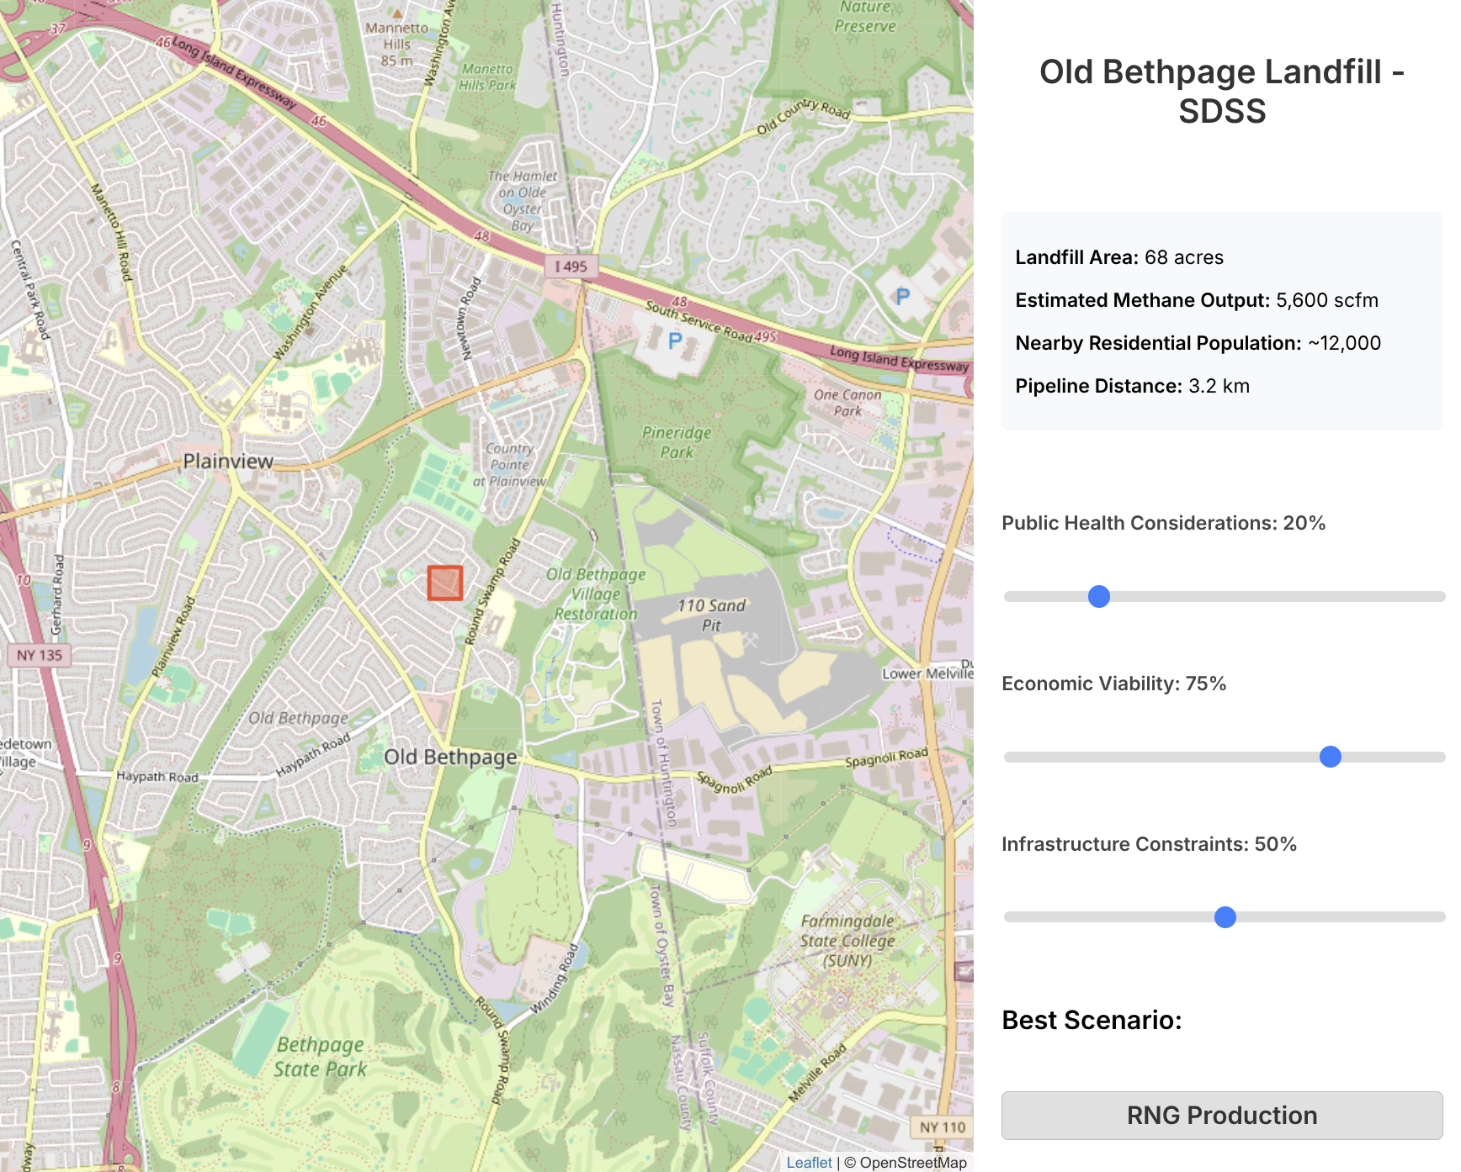

**7. Schedule / Deliverables**

**This is already messed up. Sorry.

| **Early March** | Data Collection / Setup - Gather all required datasets and references. This includes downloading EPA LMOP landfill data, state landfill inventories, EJSCREEN data, EIA infrastructure maps, and any needed regulatory maps. Also, compile emissions and technology performance data (for decision matrix) from literature. Deliverable: Data inventory and GIS database initialization. (By the end of the first month, I expect to have a working geodatabase with all relevant layers imported.) |
| --- | --- |
| **March 24th** | **Project Update Report Required** |
| **April 7th** | Model Dev. - I want to have some defined quantitative scoring system for landfill ranking (at all levels). Deliverable: Draft conceptual model documentation with specific criteria definitions and initial example rankings for a subset of sites |
| **April 21st** | SDSS Refinement - would like to run the model across a full study region (ex, the 5 boroughs). Perhaps I could validate results by cross-checking with previous successful projects. Deliverable: Some initial landfill list with recommended utilization (here on out should be variable tweaking). |
| **April 28th** | Finalize Matrix Criteria, begin work on interactive map / map portfolio. (If possible, an interactive decision support tool (e.g. a simple web-based map where users can adjust a couple of weights and see results) |
| **May 5th** | **Finalize Scoring / Selection** (Heavy tweaking based on feedback, this is likely the point where I throw away any lofty ambitions about the project and settle for what seems to work best) |
| **May 20th** | **Final Project Presentations:** Ideally would like to have:   * Report (a few pages + appendices) - * A ranked list of landfills with scores / key attributes (effectively a prioritized investment list for landfill gas projects) * GIS map portfolio or interactive map showing all assessed landfills, color-coded by priority score, and symbols indicating recommended LFG utilization type (e.g. icons for flare, engine, RNG, etc. for each top site).   (Perhaps I’m being a bit optimistic here) |

**[1]Misc.:** Case study sites/recent developments   
(If the above doesn’t work out, and I end up just working with one (or a couple* sites)

* Steuben County, New York: In March 2024, Steuben County launched its first WAGABOX® unit, converting landfill gas into biomethane. Facility injects up to 207,000 MMBtu (60 GWh) annually into the local natural gas network, supplying energy to approximately 4,000 households. ([Waga Energy](https://waga-energy.com/en/waga-energy-launches-its-first-landfill-gas-to-rng-project-in-the-united-states/))
* Franklin County, Ohio: The Solid Waste Authority of Central Ohio (SWACO) partnered with Archaea Energy to capture and convert methane from the Franklin County Sanitary Landfill. Initiative produces enough renewable natural gas to heat over 13,000 homes annually. ([swaco.org](https://www.swaco.org/284/Gas-to-Energy-Project?))
* Los Angeles County, California: The Puente Hills Landfill, once the largest in the U.S., operates a gas-to-energy facility generating more than 40 MW of power from landfill gas (significant contr. to local energy supply after swtc)

*[2]A few other points I would like to perhaps implement in my conceptual model for landfill prioritization include:*

* *Landfill status / Capacity: - (Whether the landfill is active or closed, and how much waste is in place (a proxy for remaining gas potential). Active landfills with years of operation left can support long-term projects; recently closed landfills with large waste volumes can still produce gas for decades. Older sites closed long ago may have declining gas. Waste capacity or tonnage (available via state databases or EPA LMOP) will be included. (This overlaps with methane generation potential but also captures longevity of gas supply.))*
* *Regulatory Status and Compliance - Whether the landfill is subject to NSPS/EG requirements (i.e. has mandatory gas capture) or other regulations. Landfills already required to collect gas (due to size/age) may have infrastructure in place, reducing project costs. Conversely, smaller landfills not required to capture methane may emit freely – these present opportunities for new mitigation projects but may lack existing gas wells. If implemented (I am the least keen on this) the model should consider the site’s permitted status, design capacity, and estimated NMOC emissions (to see if it crosses the 34 Mg NMOC/yr threshold​ *(epa.gov) as a factor).*
* *Environmental / Land Use constraints - Surrounding land use, sensitive environments, site characteristics, etc. I would likely use some USGS streams/aquifers data, or any maps of soil regime (which I think is absolutely pertinent here), alongside protected lands maps to identify both risk for leaching (more involved), or identify if proposed pipeline routes/project development would impact sensitive areas (floodplains, wetlands). The SDSS should incorporate exclusionary criteria here (e.g. avoid routing infrastructure through protected areas).*

*In the literal sense of the word  
<http://www.eia.doe.gov/cneaf/solar.renewables/renewable.energy.annual/chap10.html> *Want to watch out for land/watershed stresses, climate stresses, hazardous waste impacts for nearby communities, and predominant contaminant risk (NMOC makeup)[*]. Also check out which sanitary precautions (minimum liner requirements, secondary leachate collection/removal systems) are in place.[r]

**(Notes)**

*[R]Appearantly the EPA is too ‘woke’ now, so EJScreen is (likely temporarily) down. I was able to find an unofficial ‘backup’ version of the tool* [*here*](https://screening-tools.com/climate-economic-justice-screening-tool) *for the time-being*

*[†]USGS’ hydrological conditions viewer (*[*https://ny.water.usgs.gov/maps/li-dtw/*](https://ny.water.usgs.gov/maps/li-dtw/)*):  
“ This web map application displays a snapshot of hydrologic conditions in the upper glacial, Magothy/Jameco, and Lloyd/North Shore aquifers on Long Island following four synoptic measurements of groundwater elevation in 2006, 2010, 2013, and 2016. Depth-to-water, potentiometric surface contours, and the northern extent of the aquifers are viewable for each synoptic datum” (data from National Water Information System Site:* [*https://nwis.waterdata.usgs.gov/nwis*](https://nwis.waterdata.usgs.gov/nwis)*) - useful for both surface water and groundwater params)*

[*] *NMOCs usually make up less than 1% of landfill gas. EPA identifies 94 NMOCs in their 1991 report, "Air Emissions from Municipal Solid Waste Landfills - Background Information for Proposed Standards and Guidelines." Many of these are toxic chemicals like benzene, toluene, chloroform, vinyl chloride, carbon tetrachloride, and 1,1,1 trichloroethane. At least 41 of these are halogenated compounds. Emphasis for SDSS would include waste makeup and dioxin/furan risk - When halogenated chemicals (chemicals containing halogens - typically chlorine, fluorine, or bromine) are combusted in the presence of hydrocarbons, they can recombine into highly toxic compounds such as dioxins and furans; When halogenated chemicals (chemicals containing halogens - typically chlorine, fluorine, or bromine) are combusted in the presence of hydrocarbons, they can recombine into highly toxic compounds such as dioxins and furans; burning at high temperatures doesn't solve the problem as dioxins are formed at low temperatures and can be formed as the gases are cooling down after the combustion process. Will determine plant type and general options (flaring, burning, boiler, etc.).*

*[r]A New York study of 38 landfills found that women living near solid waste landfills where gas is escaping have a four-fold increased chance of bladder cancer or leukemia.*

**Citations (Preliminary)**

1. U.S. EPA – **Landfill Methane Emissions and Trends**. *Inventory of U.S. Greenhouse Gas Emissions and Sinks: 1990–2022*. (Data indicating MSW landfills are ~14.4% of U.S. methane emissions in 2022, ~120 MMTCO₂e)
2. "Methodologies for Quantifying Pollution Prevention Benefits from Landfill Gas Control and Utilization," EPA document #600SR95089, July 1995.
3. U.S. EPA – **AP-42 Emission Factors for Landfills** (1998). (Provides emission factors for flares, engines, etc., used as background for comparing emissions profiles of LFG utilization technologies).
4. U.S. EPA – Resource Conservation and Recovery Act (RCRA) Subtitle D - Criteria for MSW Landfills. 40 CFR Part 258 (1991). **(Established requirements for liners, groundwater monitoring, closure, and gas migration control for landfills)
5. "The Inventory of Sources of Dioxin in the United States," EPA/600/P-98/002Aa, April 1998.
6. Caponi, Frank R., Ed Wheless & David Frediani, ["Dioxin and Furan Emissions From Landfill Gas-Fired Combustion Units,"](https://energyjustice.net/lfg/LFG-caponi.pdf) County Sanitation Districts of Los Angeles County, 98-RP105A.03, 1955 Workman Mill Rd. Whittier, CA 90607.
7. "Investigation of Cancer Incidence and Residence Near 38 Landfills With Soil Gas Migration Conditions, New York State, 1980-1989," State of New York Department of Health, (Atlanta, Ga: Agency for Toxic Substances and Disease Registry, June, 1998). Available from the National Technical Information Service in Springfield, Virginia [800-553-6847]; request publication PB98-142144.
8. U.S. EPA Landfill Methane Outreach Program (LMOP) – Landfill and LFG Project Database (2024).   
   **(Records of 542 operational LFG energy projects and 444 candidate landfills, illustrating the scope for new projects)​
9. "Air Emissions from Municipal Solid Waste Landfills. Background Information for Final Standards and Guidelines." Document # is EPA-453/R-94-021. December 1995, 311 pages. <http://www.epa.gov/ttn/atw/landfill/landflpg.html#TECH>
10. "Methodologies for Quantifying Pollution Prevention Benefits from Landfill Gas Control and Utilization," EPA document #600SR95089, July 1995.
11. The EIA data I scraped (forms 923/860) - maybe can add in temporal analysis?
12. “SIXTH FIVE-YEAR REVIEW REPORT FOR THE OLD BETHPAGE LANDFILL SITE” (27 pp, 9.84 MB), 07/27/2022609946 EVANGELISTA, PAT (US ENVIRONMENTAL PROTECTION AGENCY)